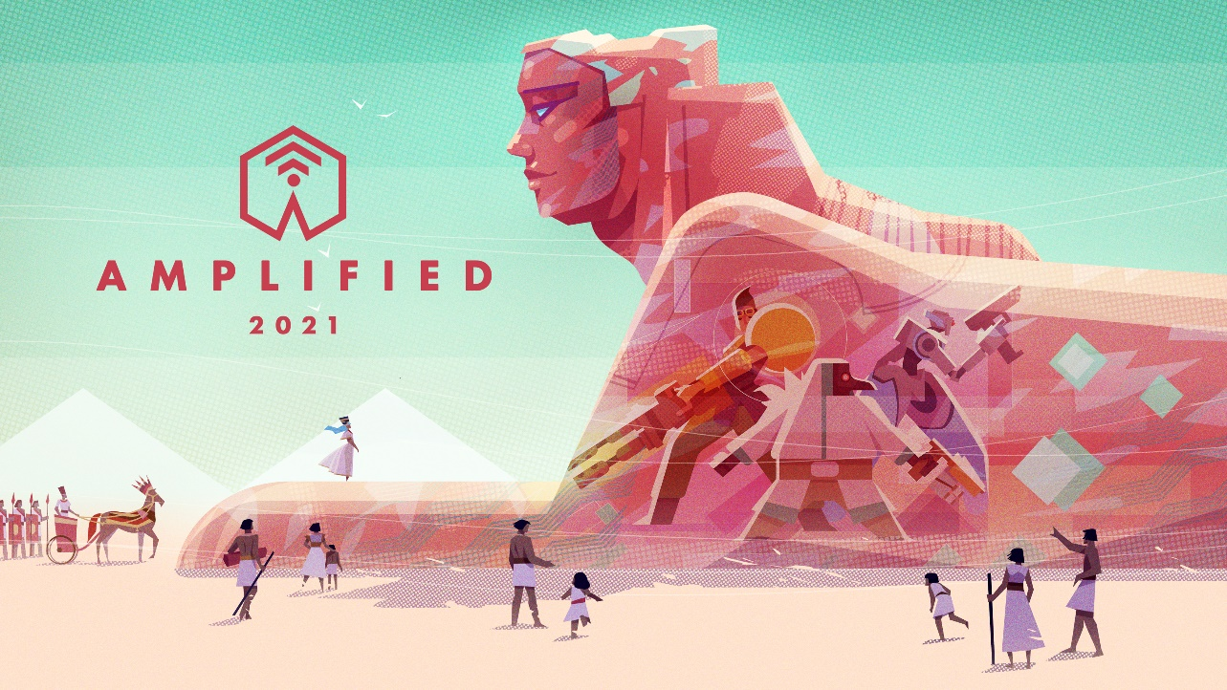

AMPLIFIED ’21: AN ENDLESS FREE WEEKEND, NEW DLC, STREAMS, FREEBIES, and MORE

As a part of “Amplified 2021” a celebration of Amplitude’s 10-year anniversary, we’ll be hosting a free weekend, sales up to 75% off, and launching pre-orders for new quest DLCs “Dark Matter” & “Monstrous Tales”.

Paris, January 21st – Every January, we get together and celebrate the anniversary of Amplitude Studios’ founding. Up until now we’ve called this event “the Endless Day”, but with HUMANKIND, our turn-based historical strategy game coming out soon, we’ve decided to rename the event AMPLIFIED, so that all our different titles can be included. Plus, this year is extra special because it’s the studio’s 10-year anniversary!
To celebrate, we’re running an event from January 20th – 24th that will include new content and a free weekend. Here’s some of what we have planned:

ENDLESS DEFINITIVE EDITIONS + PRE-ORDER NEW MINOR DLCs
Today we’re excited to be releasing the Definitive Editions for the Endless games! We’re also debuting the new Endless™ Universe logo with an Endless™ Universe franchise trailer and launching pre-orders for 2 new DLCs. These quest-focused packs are perfect for lovers of the Endless universe who want to dive further into its lore:
- Endless Space 2™ – Dark Matter: 12 new quests that view the Endless Universe from the underbelly of events and discoveries that have, on occasion, been dark indeed…
- Endless Legend™ – Monstrous Tales: 20 new tales are enriched with monsters and myths from the depths of Auriga's mysterious and menacing history; a tapestry of friends and foes, hope and horror.

PLAY ALL OF THE ENDLESS GAMES FREE THIS WEEKEND
That’s right, from now through Monday at 10AM PST, try out Endless Space 2, Endless Legend, and Dungeon of the Endless free on Steam.
If you enjoy yourself and want to nab the games forever, they’re discounted up to 75% off!

FRIDAY JANUARY 22nd IS HUMANKIND DAY
If historical strategy is more your speed, we’ve got some special HUMANKIND content planned as well. During our HUMANKIND stream from 17:00 to 19:00 CET on the 22nd, we’ll be enabling Twitch drops. You’ll be able to collect ingame avatars of your favorite streamers by watching a total of one hour stream time!
We’ll also be dropping HUMANKIND Feature Focus video on Avatar AI tomorrow. In HUMANKIND, each avatar will have it’s own personality that can be set by the user. You can then share it with your friends, so they can then play against you even when you’re offline.

MORE FREEBIES AVAILABLE ON GAMES2GETHER
Players are also invited to create a free account on our game co-creation site Games2Gether and collect the following freebies courtesy of ourselves and SEGA®!
- Virtua Fighter 2 (Free game!)
- Endless Space 2 Artbook
- HUMANKIND Wallpapers

We hope you enjoy!

- The Ampliteam

